1. Dashboard of IAM

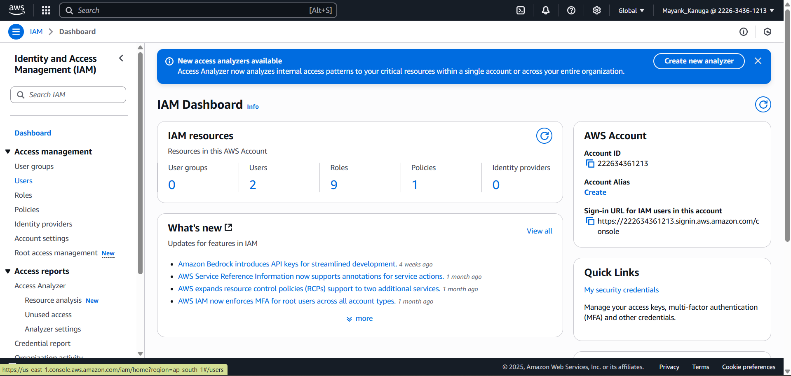

1. Go to Users

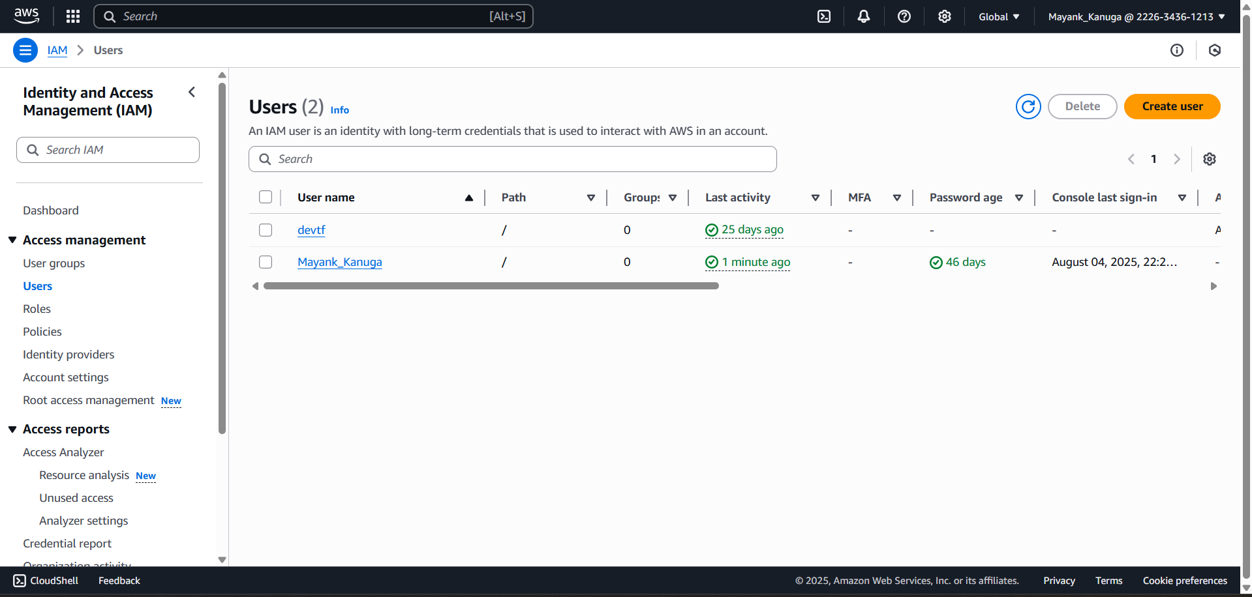

1. Click on Create User

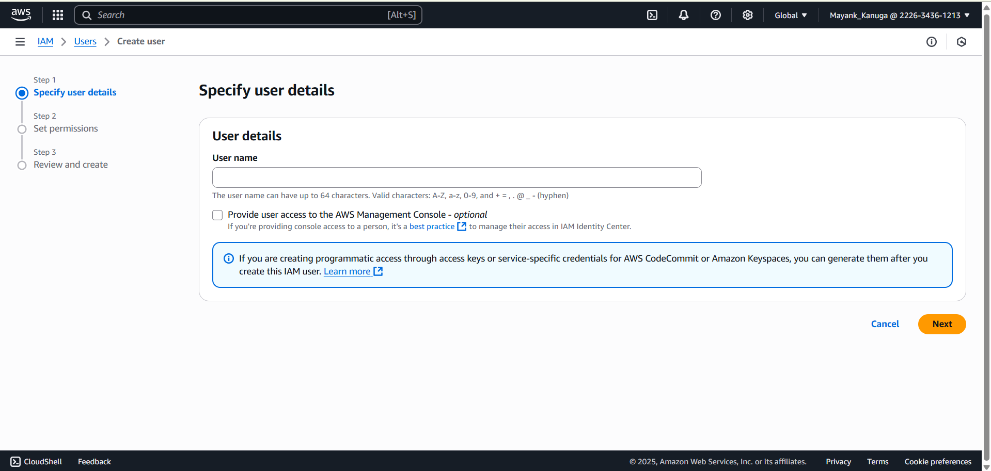

1. Enter a User details and if you want to provide that user AWS Management console then click tick on that option and select password option for console password.

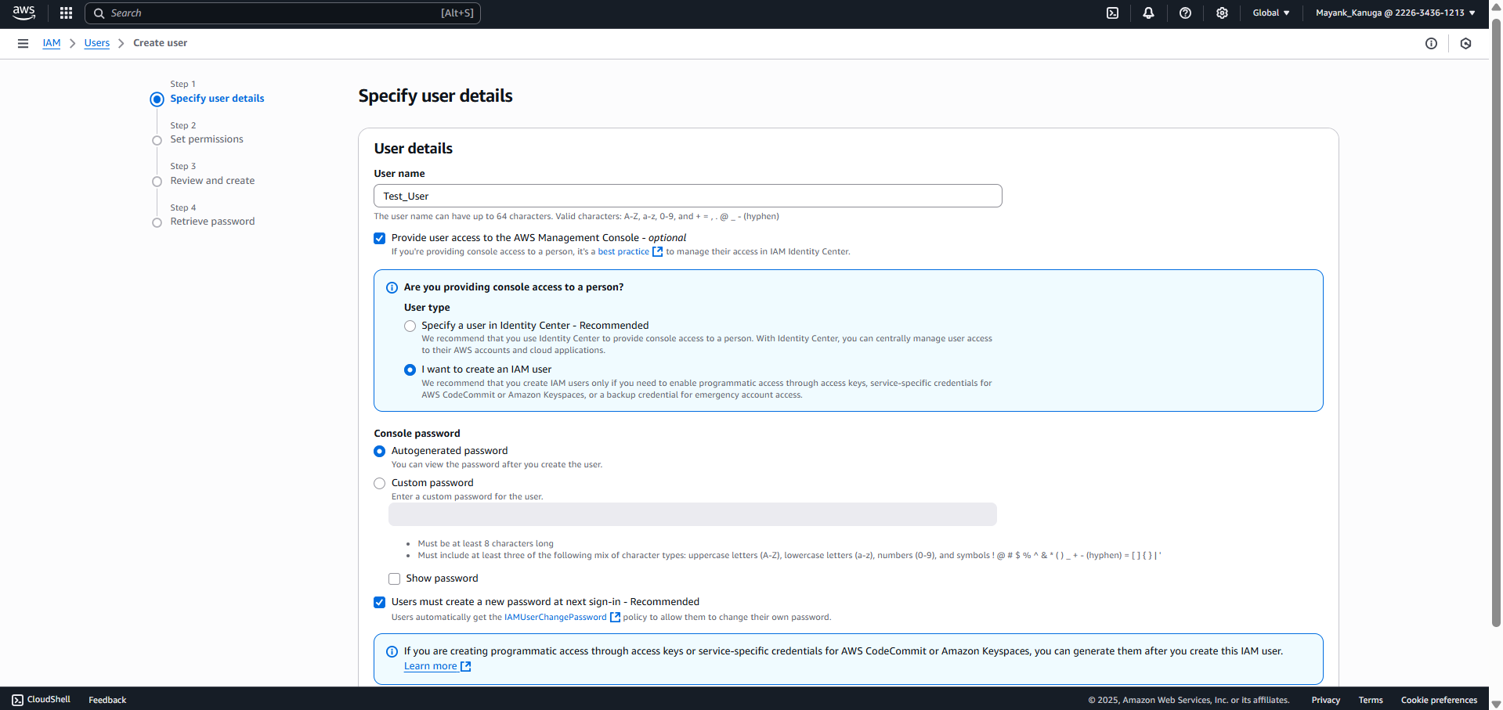

1. Click next and then select permission option in permission tab.

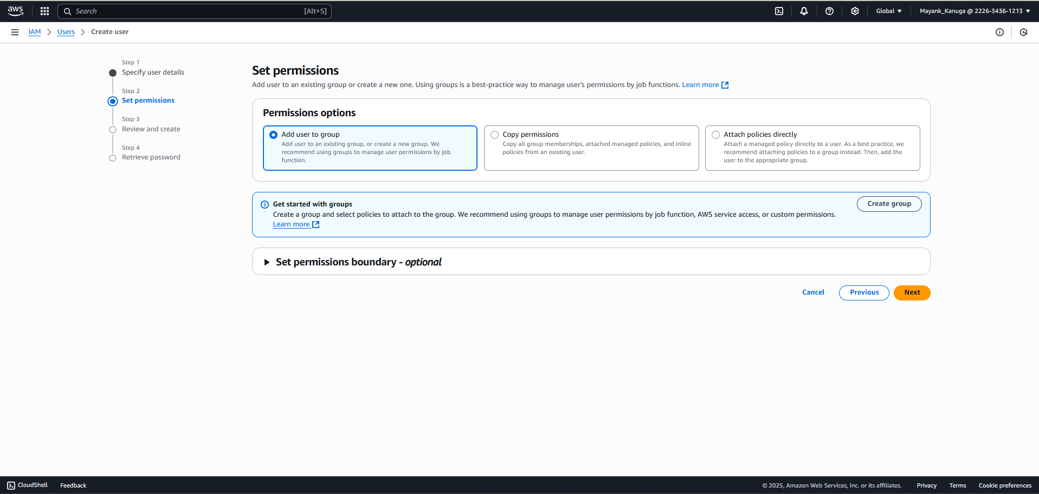

1. Click on next nad it shows review and creat and select next

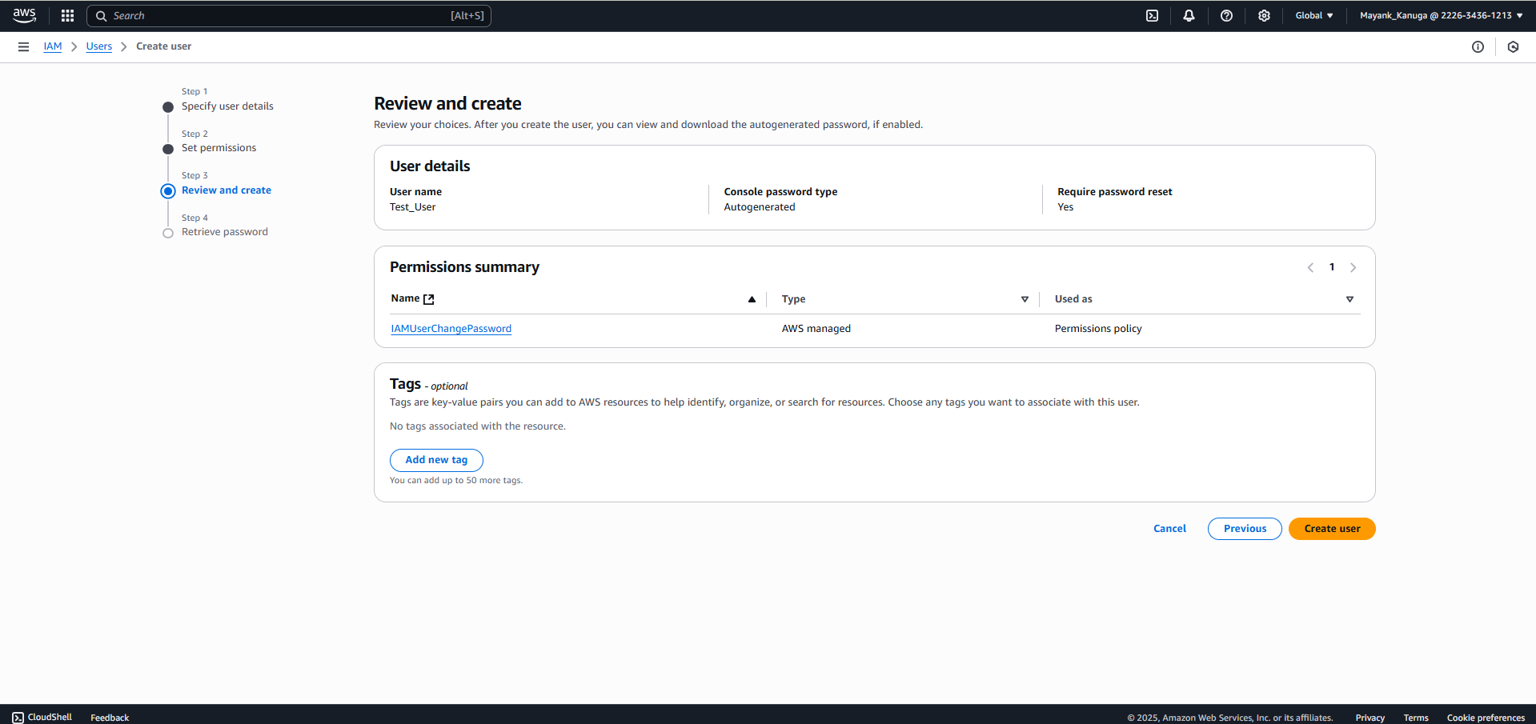

1. Its showing final for Created option.

